**ME2400-Measurement Instrumentation and Control**

**Project Report by**

**GROUP 17**

**Veerendra Harshal Budhi- ME17B124**

**Sujay Bokil- ME17B120**

**Harshal Katari- ME17B146**

**Deepu Raneesh- ME17B138**

**Abstract**

First step that we have taken was to get a proper understanding of the  
problem statement. After thinking carefully about the feasibility of  
various solutions that our group came up with, we finalized on the  
physical model of our bot. We have made a CAD design of the model  
and attached it to the report below. The sensor that we have decided to use is HC-SR04 Ultrasonic sensor. Actuation will be done by a  
servo motor. We are planning to use wood for the main structure and steel for the supporting rod.  
The reasons for using these are stated below. We have also decided  
on all the electronic components and other materials that we will be  
using. In the coming days, we will try to get a deeper understanding about the components of the to-be built mechanism and start making it.

**Mechanical Design**

**Design Brainstorming**

1. The mechanical Design of the Project was made with the following in mind.

*The servo actuation should be as efficient as possible.*

1. The servo to beam power transmission is made with minimal number of components.

*It should incur as less backlash as possible.*

1. The couplers should be made with sturdy material that doesn’t wear out.

*The Energy and power requirements are optimized.*

1. The shaft is connected through the center of mass of the beam.

*The frame should however be sturdy enough to not get affected by vibrations of the ball.*

1. The motor doesn’t allow for unprepared movements and has sufficient stall torque

*Length was chosen to be 200 mm and shall be increased iteratively.*

The materials used will be

**Wood** for the Main structures

*We will make these from plywood strips and planks available in market.*

**Steel** for the supporting rod(axle).

*This is available in the market. We can customize available products like screws or Buy the rod cross section itself.*

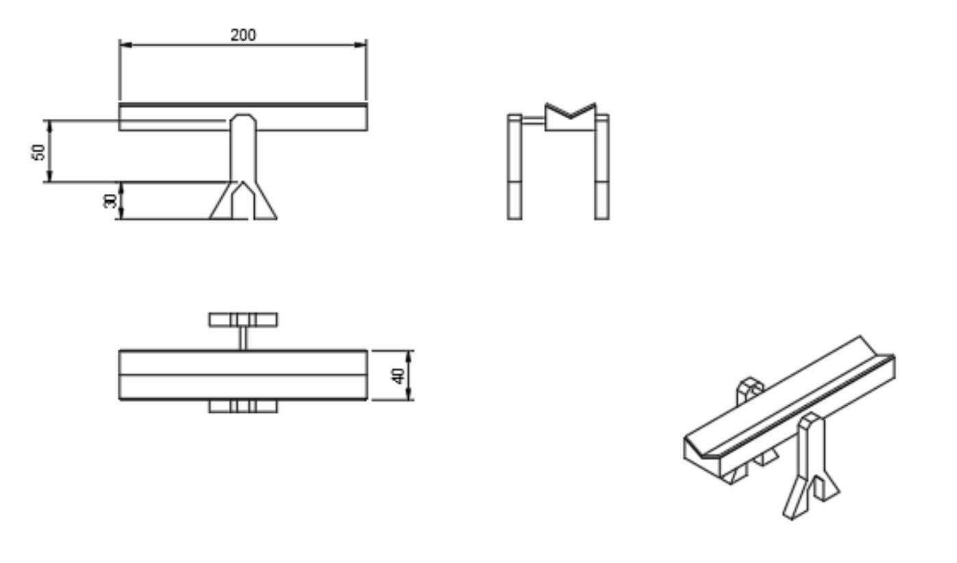

The actuation will be done by a servo motor.

*And hence the beam connection to the servo motor will be done on the support structure*. *The gap between the structures shall place the servo and the battery pack.*

**Choice of Sensors**

The sensor which we are going to use is HC-SR04 Ultrasonic Sensor. The specifications required are a range of at least 30 cm, small enough dimensions to be fitted on the beam and high resolution. The specifications of the sensor are

* Power Supply :                   +5V DC
* Quiescent Current :            <2mA
* Working Current:                15mA
* Effectual Angle:                   <15°
* Ranging Distance :              2 cm – 400 cm
* Resolution :                         0.3 cm
* Measuring Angle:                30 degree
* Trigger Input Pulse width:   10uS
* Dimension:                          45mm x 20mm x 15mm

Also, the cost of the sensor is below 100 Rs. which is why we preferred it over other types of sensors such as capacitive sensors because they have high prices for the same range of output.

**Control Elements**

The only correction element or actuator required here is a servo motor to change the angle of the beam according to the ball position. Here we don’t use a stepper motor because it changes the speed of rotation while a servo motor can change the angle which is the required task. The servo motor we are going to use is  SG-90 Tower Pro Micro Servo Motor. Here are the specifications.

Modulation: Analog

Torque: 4.8V - 1.8 kg-cm

Speed: 4.8 V - 0.12 sec/60 degree

Weight: 9 gram

Motor Type: 3-pole

Gear type: Plastic

**Signal Conditioning Elements**

We are using an Arduino Uno which has an inbuilt micro controller, analog and digital input pins and digital output pins. As we are using an Arduino board, we don’t exclusively need a comparator to generate the error signal. An ultrasonic sensor detects the signal position of the ball. The output ball position is compared to the setpoint (the position where we want the ball). The PID algorithm on the Arduino is used to compute the angle of the servo motor based on the difference between the output ball position and the set point (the error).

**Electronic Components**

**HC-SR04 Ultrasonic Sensor:** The range matches our range of use and the    dimensions are small enough to mount on the beam.

**SG-90 Tower Pro Micro Servo Motor:** The torque of the motor is 1.8 kg-cm which is apt for our use and weight and cost factors are also favorable.

**Arduino Uno:** A device resembling a differential operational amplifier is required to calculate the difference between the actual output and set value but as we have an arduino we don’t need to separately use an op-amp**.**